# 

# Stuff you should know before using this

(Last update: 05-2-2024)

This was made by an idiot, so expect mistakes.

This information was mainly gathered from my experience with arch, the arch community discord server (<https://discord.gg/zwX5yUPbFn>), the arch wiki, DuckDuckGo and the r/linuxquestions community.

Text that is *tilted* should be changed, often you will see info on what you should input in the tilted field, and additional information after //, like this: 'cd *TheDownloadDirectory* // change the tilted field with your download directory'

For even more additional information, after a paragraph i include the title of information page to look for, eg: ‘(init systems)’. In this example for more information you should look for ‘init systems’ in the ‘Additional information’ chapter.

If you want additional information on a package, term or instructions for properly configuring something then i would highly recommend the arch wiki, it helped me more times than i can count (https://wiki.archlinux.org/)

If you see any mistakes, have questions or have any tips then you can contact me on discord (werlon) or gmail ([werlon1495@gmail.com](mailto:werlon1495@gmail.com))

## List of Contents

**Stuff you should know before using this 1**

List of Contents 2

Abbreviations and frequently used words 2

Basic 2

Advanced: 3

Extra 3

Must-know commands 3

Partitioning 4

Network 4

Always enable: 4

Configuration: 4

Extra 5

Users, groups and sudoers 5

How to check all your users and groups 5

Add users 5

Make groups and apply users to them or remove groups from user 5

Add sudoers 6

Setting up a GUI (dm, de, wm and X) 6

Fonts 6

Configurations 7

Example configurations: 7

Enable tap to click on Xorg 7

Useful commands 8

Useful info: 8

Errors I encountered and a fix for them 8

locale error 8

End 9

## Abbreviations and frequently used words

These are the abbreviations and words that will be used in this cheat sheet or that you could encounter while using linux or while browsing the wiki.

### Basic

These are words that would be good to know if you are going to run linux.

Terminal: this is a text based interface without a gui where you type all your commands in, on most linux distributions it is using the shell language.

Gui: Graphical User Interface (also pronounced Goo-i), You can see a gui by looking at your pc desktop where you can see icons, the start, the taskbar and the wallpaper on your background, and where you can interact with them by just clicking. (The opposite of a gui is a plain terminal where you can only interact with your keyboard/text)

Example of gui, in this case old gnome:

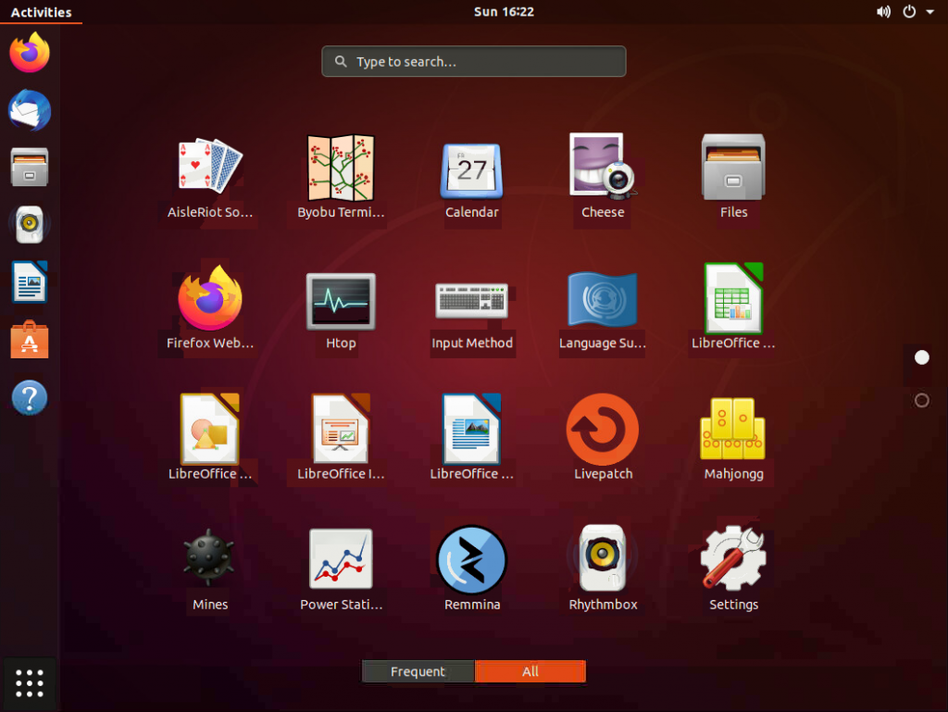

Tty (On linux): Basically the virtual terminal which you can access with ctrl+alt+f1 to f12, it is provided by default (from what i know) for every linux distribution, you can see an example of a tty in the image below.

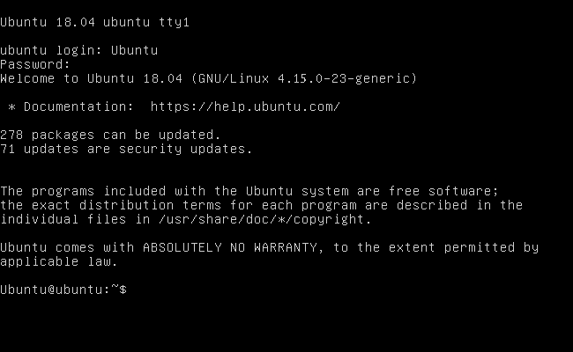

Linux distributions/distro: different forks of the base linux kernel with their own security patches, package managers and installation methods, eg. Arch, Ubuntu, Kubuntu, Manjoro, Fedora, mint etc.

Every distribution has its upsides and downsides, so I recommend distro hopping to find out what suits you.

### Extra

Fork: A modified version of the original made by another creator e.g:

Original: Ubuntu made by Canonical Ltd.

Fork: Kubuntu made by Kubuntu devs.

## What linux distribution should i use (for my first time)?

Starting to get to know linux and installing it for yourself is a difficult process, made more complicated by the abundance of choice, luckily you have me to help you out. Even if you are already knowledgeable about linux there is still maybe interesting recommendations for you and information you should know.

In the end, there is no definitive best choice, it all depends on what you want your system to be and look like. The only major difference (besides ease of installation) is the package manager included in the distribution, for example: apt, pacman, dpkg.

However i will still try to give you an objective and my own subjective look at the most popular ones.

Mint



Debian



Ubuntu



Arch



Arch linux has the recognisability from the meme “I use Arch btw.” and its difficulty for beginners.

Gentoo



## Must-know commands

'systemctl' is a program that controls all daemons and makes sure that they start when the system boots, not every distribution comes preinstalled with it though but most use systemctl. Alternatives include OpenRC, runit, etc. (init systems)

'ls' is used to list all items in the directory, e.g 'ls /bin' will show all files and directories in /bin, most of the time they are colored based on their type

'cd' is used to change your working directory in which your terminal executes commands, e.g 'cd /bin' will change your directory to /bin, if you type ls without any path set it will show all directories and files in /bin

## Partitioning

The EFI partition MUST be FAT32.

The boot partition MAY be the same one as the EFI one

The root filesystem MUST be a Linux-friendly filesystem. EXT4 is a fine choice for a no-frills setup, but it COULD be XFS, BTRFS, etc.

Example:

/dev/vda1 -> 1GB of FAT32 mounted as /mnt/boot/efi EFI

/dev/vda2 -> 20GB of EXT4 mounted sa /mnt ROOT

/dev/vda3 -> 4GB of SWAP mounted as swap.

## Network

**NEEDS EDITING TO INCLUDE SIMPLER OPTION OF NETWORKMANAGER**

### Always enable:

Option Mostly automatic (easy):

NetworkManager

Option Manual (difficult):

systemd-resolved

systemd-networkd

iwd (named iwctl as command)

### Configuration:

Dns in /etc/resolv.conf :

nameserver 8.8.8.8 # The 8.8.8.8 is an example and uses google's dns server

You need to make a file in /etc/systemd/network/*yourname*.network (you can replace *yourname* with any name u want, as long as it ends in .network) and fill this in:

[Match]

Name=*devicename*

[Network]

DHCP=yes

# You can replace *devicename* with the device of your choosing, most of the time named wlan0 or enp1so, i will tell you how to check your device name in Extra, but if you want both then you can place an asterisk * and it will try to connect all available devices.

If 'ip link' still says your *devicename* is down then you can enable it with 'ip link set *devicename* up', if you want to disable *devicename* then replace 'up' with 'down'

After that you need to add a hostname (the name of your device that will show on your network), make a file in '/dev/' named 'hostname', like this '/dev/hostname' in that file you can give it any name.

### Scanning network for ip addresses & hostnames

The easy command for scanning a network is ‘nmap’, it also has options for port scanning however I currently don’t have the necessary knowledge for it.

To scan without ports: ‘nmap -sn “192.168.1.*/24”

IMPORTANT: Not every router configures a network on 192.168.1.1-254, to check the network that your device is on, execute ‘ifconfig’ in terminal and locate the network interface you are using (it is most probably the network interface that is UP in ‘ip link’) and you can see what kind of ip address your device has and the subnet mask.

If you are using another tool to identify your device ip, keep in mind that the subnet mask is sometimes noted as ‘/24’, with 24 the number of bits in the subnet mask.

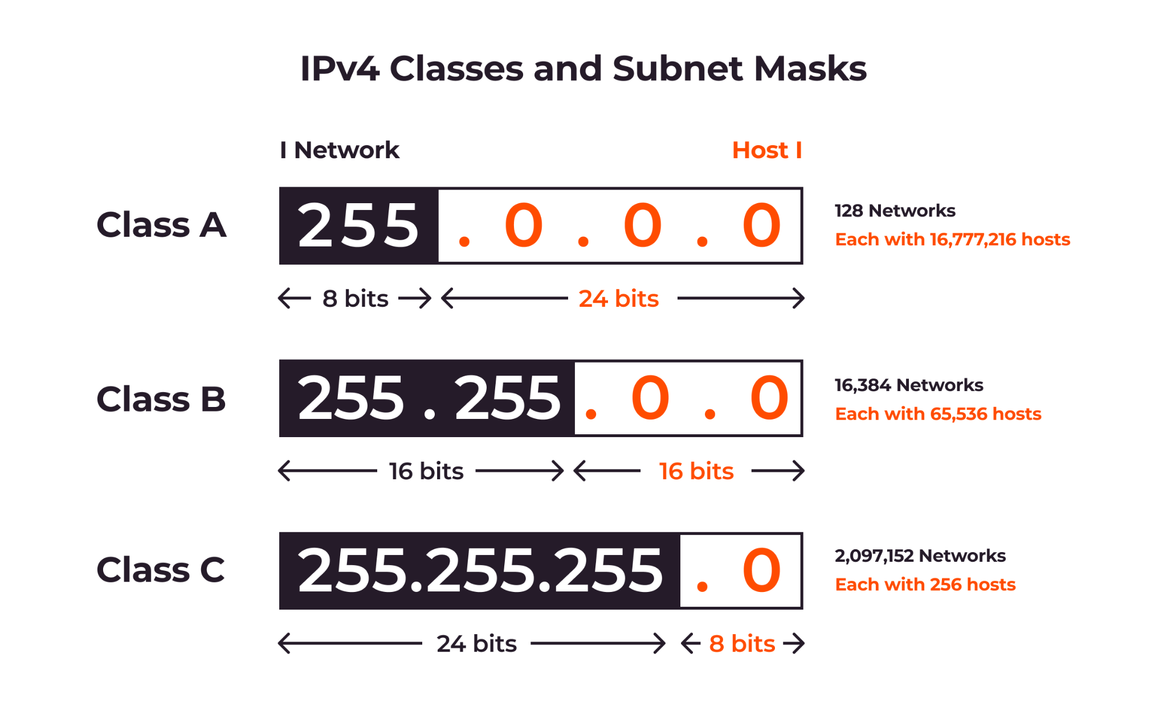

(Source of image and extra info: <https://gcore.com/learning/what-is-a-subnet-how-subnetting-works/>)

### Extra

With 'ip link' (no quotes) you can see all available devices and also see if they are on or off with the state being either UP, DOWN or UNKNOWN.

## Users, groups and sudoers

### How to check all your users and groups

Users:

cat /etc/passwd

Groups:

cat /etc/group

### Add users

To add users you can use the command 'useradd', the most simple way to do it is 'useradd -m -s /bin/bash *USERNAME*' this will make a user with a home directory (/home/*USERNAME*/)

### Make groups and apply users to them or remove groups from user

To make groups you can use groupadd, e.g: 'groupadd *GROUPNAME*', to apply a group to a user you can use 'usermod -aG *GROUPNAME USERNAME*'.

To remove groups from a user then you can replace *GROUPNAME* with *USERNAME* as when you create a user it creates a group for that user.

### Add sudoers

To edit sudoers (users that can use the sudo command to edit and execute root files) use: 'EDITOR=*editor* visudo' // Replace *editor* with your text editor of choice, for example: nano, vim, emacs.

After you're in nano you should see the sudoers file, to add a group or user use the example below:

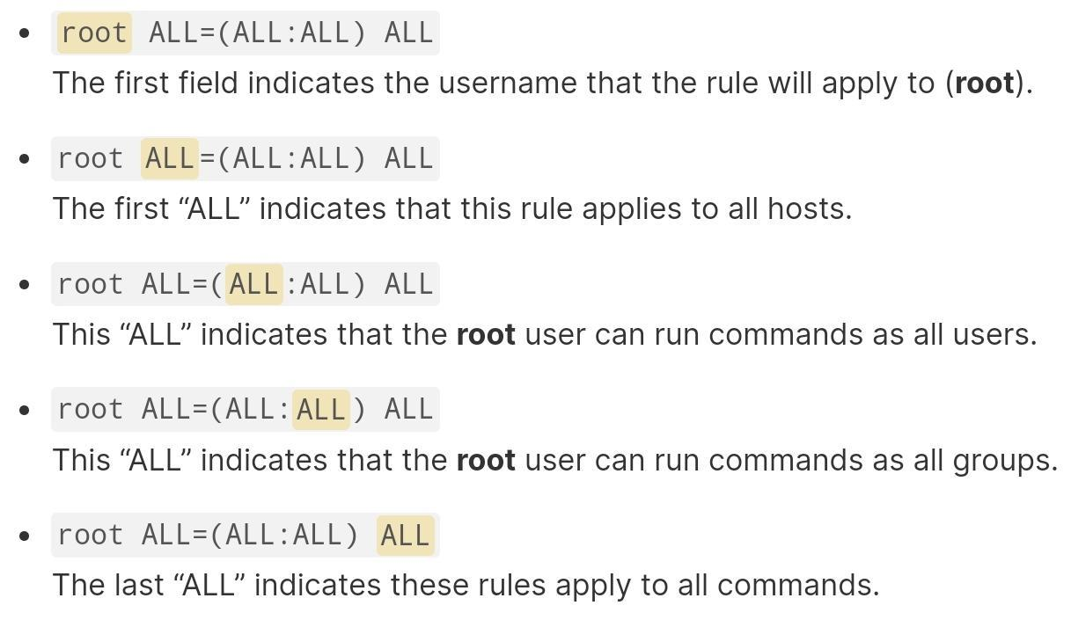

E.g: 'werlon ALL=(ALL) ALL'

(Note that if you want to use a group then you need to add a % before it, like %thecoolkids ALL=(ALL) ALL)

## Setting up a GUI (dm, de, wm and X)

Coming soon

## Fonts

Most fonts are located at /usr/share/fonts/ or /usr/local/share/fonts/, if u want to add a font then u need a .ttf file of the font, e.g: <https://www.jetbrains.com/lp/mono/>

Add the ttf file to on of those font folders and refresh your fonts cache with ‘fc-cache’, after you refresh u can list all your fonts with ‘fc-list’, u can pipe the output to grep to find your font or you can put the name after fc-list, like this ‘fc-list *jetbrainsmono*’, u can replace *jetbrainsmono* with your font. fc-list will give you the family and style of the font, e.g family jetbrains mono and style regular.



(Fonts)

More info: https://wiki.archlinux.org/title/Fonts

## Configurations

### Example configurations:

https://github.com/MarcelWalk/dots # Nyasaki configurations.

If you want to change your de then you will need to do so in your greeter.

Config files for your terminal emulator (like Konsole or alacritty), window manager (like i3 or dwm) etc are in the user's home directory (configs for daemons (background processes), and other services that are for the whole system are in the root directories, like /etc/systemd/)

To change resolution download xrandr and add this line to your window manager (like i3): exec xrandr --output Virtual-1 --mode 1920x1080 https://wiki.archlinux.org/title/xrandr

If you want to change your background you can use feh or other applications that you like, for feh you need to run the command: feh --bg-fill /PathToPhoto (you can also make to automatically do it for you in the window manager config file, just add: exec CommandYouWantToBeExecuted)

Info about directories:

/etc/systemd/system/ is the location of local .service files

### Enable tap to click on Xorg

Packages required: xinput, libinput

execute: ‘xinput’ to list all input devices, it should be under ‘Virtual core pointer’ and you should remember the id that is after the device name.

Next execute this to change the configuration of your device: ‘xinput set-prop *YourDeviceId* "libinput Tapping Enabled" 1’ # don’t forget the double quotes.

To view your device configuration execute: ‘xinput list-props *YourDeviceId*’

Source: https://xtrymind.wordpress.com/2017/03/11/enable-tap-to-click-on-openbox/

## Useful commands

Sysrq (is also the print screen button)

By holding alt and pressing sysrq, then pressing a key, it will make the kernel stop doing whatever it is doing to do a specific task. The help menu for all keys is Alt(hold)+sysrq(press)+h(press).

<https://docs.kernel.org/admin-guide/sysrq.html>

ls /Directory | grep AnythingYouWantToSearch

man *CommandYouWantToLearnMoreAbout*

## Useful info:

Piping is the use of | between 2 commands or more to transfer the output of the first command to the input of the second command, e.g 'cat /home/werlon/coolsites | grep discord' this will read the output

Greeter is a gui login screen that can be changed in the dm (desktop manager), e.g. for lightdm you go to /etc/lightdm/lightdm.conf and add the line there

To check your laptops battery install the package 'upower' and execute 'upower -e', after that you can check your battery status with 'upower -i /org/freedesktop/UPower/devices/battery_BAT0'

to make a .service file (which will be run as root) you need to make a YourNameHere.service file and add in:

[Unit]

After=mysql.service

[Service]

ExecStart=/PathToShellExecutable

[Install]

WantedBy=default.target

After:Instructs systemd on when the script should be run. Here it will start after mysql.service, it can be different.

ExecStart:Full path to executable.

WantedBy:Into what boot target the systemd unit should be installed.

## Errors I encountered and a fix for them

### locale error

if u have locale problems with something, execute: 'locale' (no quotes), and it should be: '<https://paste.rs/fCX>' to fix this u need to make a file in a directory, should be like this: '/etc/default/locale' (no quotes) and then paste this into the locale file: 'LANGUAGE=en_US.UTF-8 LANG=en_US.UTF-8 LC_ALL=en_US.UTF-8' (no quotes). After that execute: 'sudo locale-gen en_US.UTF-8' (no quotes). it may give u an error that it can't change LC_ALL but it should be fine, if u execute 'locale' again then u won't see any errors. I got this fix from<https://snippets.aktagon.com/snippets/614-how-to-fix-bash-warning-setlocale-lc-all-cannot-change-locale-en-us->

## Additional information

## End

Made by: Werlon